JK/KINDERGARTEN
2-Boxes of Kleenex
1-Backpack to carry daily work (without wheels)
1-Box of colored pencils (Crayola set of 12)
2-Expo dry erase thin tip markers (no yellow)
2-Expo dry erase thick tip markers (no yellow)
1-Bottle of Elmer’s glue (4 ounce)
4-Glue Sticks
2-Boxes of crackers
1-Pair of headphones for computers/iPads (earbuds are too big for little ears)
1-Extra change of clothes
1-Pack 8-10 count Thick Tip Markers
JK- 1 box of drawstring Trash Bags
Hill- 1 box of Ziploc Snack Bags
Jobe- 1 box of Ziploc 2 Gallon Bags
Kirsch- 1 box of Ziploc Sandwich Bags
Morrison- 1 box of Ziploc Gallon Bags
*Your child does NOT need a rug or mat

FIRST
1- Elmer’s white glue
2- Glue Sticks
2- Pocket Folders with fasteners
2- Large boxes of facial tissue
2- Boxes of 24 crayons (No larger counts)
10- Regular size #2 yellow lead pencils (No mechanical)
1- Pink soft rubber eraser
1- Highlighter
1- Pack of colored pencils
1- Spiral notebook
1- Container Lysol wipes
1- Fiskars Scissors
1- Book bag to carry daily work
2- Boxes of crackers (saltines, graham, animal)
4pk-Expo dry erase markers
1- Pair of headphones/earbuds
1pk- 8 Washable markers
1- Small bottle of GermX
Girls- 1 Box Quart size Ziploc Bags
Boys- 1 Box Gallon size Ziploc Bags
**LABEL all items with the child's name (with black sharpie)

SECOND
1- Book bag to carry daily work
3- Glue sticks
10- #2 Ticonderoga Pencils
2- Soft pink rubber erasers
2- Large boxes of facial tissue
1- Box of crayons (48 or less)
1- Spiral notebook, wide rule, 70 pages or less
8- Dry Erase markers (No Yellow)
1- Box of 12 colored pencils
1- School box for supplies (No larger than 7”x11”)
2- Sturdy pocket folders
2- Highlighters
1- Pair headphones (no earbuds)
1- 3inch Post-it Notes pad
1- Box of Snack Crackers
1- Fiskars scissors
Boys- 1 Box Quart Ziploc bags
Girls- 1 Box Gallon Ziploc Bags
**LABEL all items with the child's name

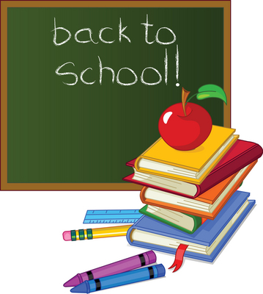

THIRD
3- Spiral or wireless wide ruled notebook (70 pages or more)
5- #2 lead pencils
3- Glue sticks
1- Box of colored pencils
4- Large dry erase marker- No Yellow
1- Small box of pencil top erasers
2- Large boxes facial tissue
4- Two Pocket folders (No Metal Fasteners or Trapper Keepers)
1pk- 8 Washable markers
1- Scissors
1- School box for supplies (no larger than 5x8)
4- Highlighters (light colors)
2- Pair of headphones
Girls- 1 Box of Quart size Ziploc Bags
Boys- 1 Box of Gallon size Ziploc Bags

FOURTH
*5- #2 Ticonderoga Pencils
1- Pink rubber eraser
1- Red checking pen or pencil (No GEL pens)
1- Folder (No binders or Trapper Keepers)
*4- Large boxes of facial tissue (2 in Fall and 2 in Spring)
1- Package of loose-leaf notebook paper, wide ruled
*6- Spiral Notebooks, 100 pages
*4- Dry Erase markers- Black only (2 in Fall and 2 in Spring)
2- Pair of headphones/earbuds
1- Glue stick
1pk- Colored pencils set of 12
Girls- 1 Box Quart size Ziploc Bags
Boys- 1 Box Gallon size Ziploc Bags

